**Heavy Cotton Long Sleeve Shirt**

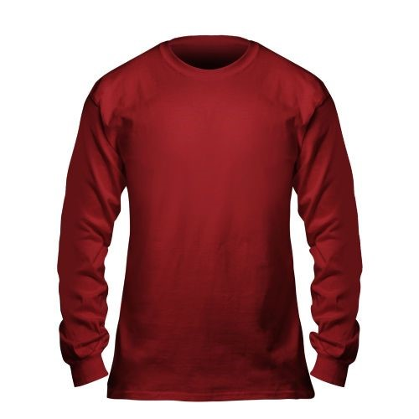**Maroon with Gold Logo**